**MID TERM REPORT**

**On**

**SMART SHELF FOR RETAIL STORES**

**By**

**Name: DEEPAK PANDEY**

**University Roll No:**

**Semester: 6**

**MASTER OF COMPUTER APPLICATIONS**

**(Batch 2014-2017)**



**CHANDIGARH ENGINEERING COLLEGE (MCA)**

**CGC, Landran, Mohali**

**INDEX**

|  |  |  |
| --- | --- | --- |
| S.No | Topic | Page No. |
| 1. | Basic Information | 1 |
| 2. | Introduction of Project |  |
| 3. | Objective of Project |  |
| 4. | H/W & S/W Requirements |  |
| 5. | Modules Introduction |  |
| 6. | DFD (1 level & 2 levels) |  |
| 7. | Class Diagrams (if any) |  |
| 8. | Data base designing (Table name with their attributes & various constraints on tables) |  |

**Basic Information**

1. **Company Name: Robert Bosch Engineering and Business solutions**
2. **Company Address:** **No. 76, 77, Cyber Park, 3rd Cross Road, Electronic City, Phase 1, Dodathogur Village, Bengaluru, Karnataka 560100**
3. **Name of Trainer: Mr Muthukumar Munuswamy (Manager)**
4. **Trainer Contact no: 9008065299**
5. **Internal Guide (Class Counselor):**
6. **Name of the Project: Smart Shelf**
7. **Front End:**
8. **Back End: Mongo DB**

**Introduction**

Digital Transformation is riding the next wave of innovation in the retail industry. E- retailers are enticing the shoppers with ‘anywhere any time’ shopping, faster delivery, personalized offers, easy returns etc. and it is a growing threat to the brick and mortar stores unless they adapt to the technology musings of the digital world. To keep in pace with the technology advancements and increasing competition from the online space, retailers are now rethinking their in- store strategies. Since the visual and sensory experience that the shoppers will get through the physical stores cannot be replicated in e- commerce space with even the most sophisticated technology, retailers are exploring ways to optimize the in-store experience by enabling innovative technologies like Smart Shelves in retail stores.

‘Smart Shelves for retail stores’ is a IOT application that aims at implementation of Smart Shelves, the electronically connected shelves which can automatically keep a track of the inventory in a retail establishment. RFID smart shelf is a regular shelf with an associated antenna reader, eventually embedded in the shelf, which ideally allows to univocally detecting all the tagged items located on that shelf only. Extending this concept to every shelf in a store makes it possible to automatically locate and inventory every item.

Smart Shelves will implement wireless inventory control system that will be fitted with Antennas. The Antennas can be built-in the shelf itself or be installed under normal shelves. These Antennas should consistently notify the back-end system about the existing quantity of items on the shelves. These wireless devices will use RFID tags and readers to scan the products in the display and stock shelves and must alert store associates when product levels are running low or when a theft is detected. It will also trigger the back-end system about the items that do not belong to certain shelves as "misplaced items".

The Smart Shelves technology can be hugely beneficial for the retailers’ selling experience. The smart shelf concept will enable the inventory and store executives to refill stocks from stock room as they get depleted from the store shelf, intimate the buying group about the demand and Out of stock situation. Inform warehouse / Direct shipment vendor for immediate replenishment. Smart Shelves should enable real time and accurate management of inventory data to empower retailers to optimize the in-store sales with the timely filling of stocks, review of items etc. Remote monitoring provision must help retailers to remotely keep a track inside the store and help in quickly identifying and fixing problems inside the store if any, before it impacts the customers.

In this age of technology proliferation and increasing demands from the customers, delivering an enriching customer experience is equally an opportunity as well as a challenge. Smart Shelves empower a retailer to deliver more focused and optimized shopping experience for the in- store retail customers. Smart Shelves technology enables the store executives to have a seamless information exchange with various participants in the supply chain. Furthermore, it is capable of proactively avoiding “loss of sale” scenarios to a larger extent. Even in this era of digital revolution and internet, brick and mortar stores still continue to be relevant for retail shopping, because of the real-time shopping experience it can provide is unmatchable with the e-commerce shopping experience. Unique and optimized in-store experiences enabled by technologies like Smart Shelves, where technology and operations go hand in hand, can lure even more customers back to the stores, thereby re-enforcing the significance of an Omni channel retail experience.

**Features of Smart Shelves System**

**Inventory Automation**: Effective inventory management is critical in managing costs, measuring shrinkage and improving the customer shopping experience in retail. With Smart Shelves technology, retailers can auto track the stocked goods and make sure there is surplus inventory to avoid being “out of stock”.

**Real time Inventory Management**: Real time inventory management enables retailers to save time, make informed decisions and optimize in-store sales. Smart Shelves enable real time and accurate management of inventory data to empower retailers to optimize the in-store sales with the timely filling of stocks, review of items etc.

**Remote Monitoring Provision**: Remote monitoring provision enables retailers to remotely keep a track inside the store. The remote monitoring capabilities of Smart Shelves help in quickly identifying and fixing problems inside the store if any, before it impacts the customers. All hardware continuously run with automatic remote alerting and dispatching capability to insure non-stop operation.

**Stock Availability Assessment**: Availability of stocks when customers ask for it is critical for any retail stores. Smart Shelves technology enables automated tracking of stock availability and informs retail store managers if the items are running out of stock or misplaced. Cross and up-selling options in the case of out of stock items Features of Smart Shelves System

**Technical Benefits**

Cross and upselling normally happen when there is a shortage of products that customers are looking for. If the retailers are already aware of the out of stock items with smart shelves technology, they can offer customers better or complementary products compared to what they are currently interested in. Offline Model Working Stores need to be functioned in offline mode also at times. Even when there is a data disconnect, smart shelves will work in offline scenarios also. Hardware Compatibility The hardware associated with Smart Shelves are compatible with any mobile network provider / any radio frequency (RF) devices / language.

**OBJECTIVES**

• Locate products easy and fast

• Reduction of ‘out-of-stock’ products

• Better optimization of in-store operations

• Store space optimization

• Better utilization of in- store human resources

• Increase in sales

• Control and monitor the usage of high value items

• Better analysis of product popularity

• Increase operational efficiency and store effectiveness

• Enhanced customer experience

**FEASIBILITY STUDY**

Smart shelves in retail store is feasible technically, economically and operationally.

**Technical Feasibility**

The technical feasibility concentrates on the feasibility of system in terms of tools and technology & justify for exploitation of the technology so as to arrive at the solution for a given problem. The application uses node js to create REST APISs. Operates on a single-thread, uses an event-driven and a non-blocking I/O approach. Single thread is used to handle multiple concurrent requests. All long-running tasks (data access, input/output) are always executed asynchronously on top of worker threads.Node.js makes this type of concurrent programming easier to utilize. This model is highly efficient and scalable as Node.js is basically always accepting requests because it’s not waiting for any read or write operations. That makes it lightweight and efficient to support hundreds of thousands of concurrent requests.

The front-end design is accomplished using Oracle JET. It is targeted at intermediate to advanced JavaScript developers working on client-side applications. It's a collection of open source JavaScript libraries along with a set of Oracle contributed JavaScript libraries that make it as simple and efficient as possible to build applications that consume and interact with Oracle products and services, especially Oracle Cloud services. Complete JavaScript development toolkit Leverages popular open-source technologies, Full lifecycle management for template based SPA, Built in accessibility support, Support for internationalization (28 languages and 190+ locales), Rich set of UI components, Advanced two-way binding with a common model layer, Powerful routing system supporting single-page application navigation, Smart resource management, Built-in mobile support.

Net beans IDE is used for development. NetBeans IDE is the official IDE for Java 8. With its editors, code analyzers, and converters, you can quickly and smoothly upgrade your applications to use new Java 8 language constructs, such as lambdas, functional operations, and method references. Batch analyzers and converters are provided to search through multiple applications at the same time, matching patterns for conversion to new Java 8 language constructs.

**Economic Feasibility**

The Economic feasibility concentrates on the varied expenses incurred by the organization in order to arrive at a solution for a given problem statement. This involves the cost of the code employed to arrive to the solution, external devices or hardware utility cost, resource cost & development time of the project.

Smart shelves for retail store is developed using free and open source technologies like node js, mongodb and oracle jet. The IDE used in development is Net Beans, which is free. Thus Monitoring system is economically feasible as this is built (developed) using these free and open source technologies.

**Operational Feasibility**

The operational feasibility measures how well the planned system can solve the problems of prevailing system and falls exactly in the scope of project which is analyzed throughout the analysis part.

Smart shelf in retail store operationally feasible because it solves the traditional problems of out of stock challange and automates the whole process.

**HARDWARE AND SOFTWARE REQUIREMENTS**

HARDWARE REQUIREMENTS

* Reader: RFID Readers
* Tags: RFID tags and Beacons
* Antennas
* VONET Wifi Bridges.
* Processor: 64-bit, four-core, 2.5 GHz minimum per core(Minimum)
* RAM: 16GB(Minimum)

SOFTWARE REQUIREMENTS

* IDE: Net Beans (v8.2)
* Database Server: Mongo DB (v3.2.9)
* Operating System: Windows 8.1
* Platform: nodejs, impinj reader.
* Environment: Visual studio code.

**TOOLS USED**

Microsoft visual Studio Code

Microsoft Visual Studio is an [integrated development environment](https://en.wikipedia.org/wiki/Integrated_development_environment) (IDE) from [Microsoft](https://en.wikipedia.org/wiki/Microsoft). It is used to develop [computer programs](https://en.wikipedia.org/wiki/Computer_program) for [Microsoft Windows](https://en.wikipedia.org/wiki/Microsoft_Windows), as well as [web sites](https://en.wikipedia.org/wiki/Web_site), [web apps](https://en.wikipedia.org/wiki/Web_app), [web services](https://en.wikipedia.org/wiki/Web_service) and [mobile apps](https://en.wikipedia.org/wiki/Mobile_app). Visual Studio uses Microsoft software development platforms such as [Windows API](https://en.wikipedia.org/wiki/Windows_API), [Windows Forms](https://en.wikipedia.org/wiki/Windows_Forms), [Windows Presentation Foundation](https://en.wikipedia.org/wiki/Windows_Presentation_Foundation), [Windows Store](https://en.wikipedia.org/wiki/Windows_Store) and [Microsoft Silverlight](https://en.wikipedia.org/wiki/Microsoft_Silverlight). It can produce both [native code](https://en.wikipedia.org/wiki/Native_code) and [managed code](https://en.wikipedia.org/wiki/Managed_code).

IMPINJ READER

Impinj’s fixed and handheld RAIN RFID readers and antennas deliver visibility of tagged inventory and assets with the performance, quality, and reliability necessary for robust Item Intelligence solutions. Impinj Speedway readers are high-performance, enterprise-class fixed readers

NET BEANS 8.1

NetBeans is a [software development](https://en.wikipedia.org/wiki/Software_development) [platform](https://en.wikipedia.org/wiki/Platform_(computing)) written in [Java](https://en.wikipedia.org/wiki/Java_(programming_language)). The NetBeans Platform allows applications to be developed from a set of modular [software components](https://en.wikipedia.org/wiki/Software_component) called modules. Applications based on the NetBeans Platform, including the NetBeans [integrated development environment](https://en.wikipedia.org/wiki/Integrated_development_environment) (IDE), can be extended by [third party developers](https://en.wikipedia.org/wiki/Third_party_developer)

ORACLE JET

Oracle JET is targeted at intermediate to advanced JavaScript developers working on client-side applications. It's a collection of open source JavaScript libraries along with a set of Oracle contributed JavaScript libraries that make it as simple and efficient as possible to build applications that consume and interact with Oracle products and services, especially Oracle Cloud services.

**TECHNOLOGIES USED**

HTML

Hyper Text Markup Language, commonly abbreviated as HTML, is the markup language used to design front end for web applications. Along with CSS, and JavaScript, HTML is an essential technology utilized to design front end, as well as to design user interfaces for mobile[48].

CSS

Cascading Style Sheets (CSS) is a language used for applying style to the front designed by markup languages[49][50]. Although most of the time this is used to set the style of web pages or front end written in HTML and XHTML, the language can be set to any XML report, including plain XML, SVG and XUL, and is material to interpret in discourse, or on other media.

NODE JS

Node.js is an [open-source](https://en.wikipedia.org/wiki/Open-source_software), [cross-platform](https://en.wikipedia.org/wiki/Cross-platform) [JavaScript](https://en.wikipedia.org/wiki/JavaScript) [runtime environment](https://en.wikipedia.org/wiki/Runtime_system) for developing a diverse variety of [server](https://en.wikipedia.org/wiki/Server_(computing)) tools and applications. Although Node.js is not a [JavaScript framework](https://en.wikipedia.org/wiki/JavaScript_framework), many of its basic modules are written in [JavaScript](https://en.wikipedia.org/wiki/JavaScript), and developers can write new modules in JavaScript.

KNOCKOUT JS

Knockout is a JavaScript library that helps you to create rich, responsive display and editor user interfaces with a clean underlying data model. Any time you have sections of UI that update dynamically (e.g., changing depending on the user’s actions or when an external data source changes), KO can help you implement it more simply and maintainable.

**MODULES**

1. **Inventory distribution module**

The asset count and asset location is tracked using this module. The asset location in terms of shelf location is determined using the Tag Read corresponding to an asset by a particular antenna. When a valid user like the admin gets through the verification/authentication process the the user will be able to search the asset location by applying filters like location name, type of product or category etc.

1. **Asset information**

The product information and the tag information is handled in this module. Set up screens are enabled in the application to manually enter data easily. Search option is enabled for the authenticated user to search for a particular product using its unique identification number/code.

1. **Automation for out of stock**

The out of stock feature is automated through the smart shelf and the notification system is handled in this module. Notification can be sent via sms or through mobile application.

1. **Automation for misplaced item**

The misplaced items are identified by the shelves and the notification is sent to the stock clerk and the store manager.

**SYSTEM ARCHITECTURE**

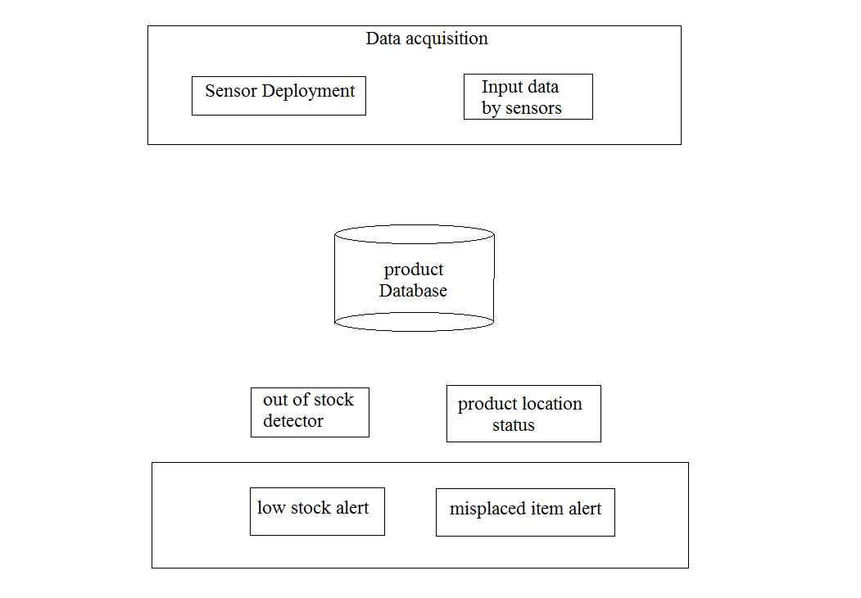

**DFD – 0 level**

Out of stock process

